Week 8 – Internet Protocol

A pic here…

**Class:**

**Student numbers:**

**Student names:**

Date: Aug 2019  
Version 1.0

# Linux, Static IP address / Subnet configuration

Linux, Static IP address/subnets configuration

Task 1: Do Linux Tutorial

Go to <http://www.ee.surrey.ac.uk/Teaching/Unix/unix2.html> and do the 2nd basic Unix tutorial.

Provide screenshots of all exercises 2a and 2b. Do all subsections of this tutorial – all of them are really useful! This task should be done individually, so there will be two sets of screenshots provided.

Task 2: Build A Simple Netkit Network

Read the explanation of the basic Netkit commands and use them to build a simple network of two nodes connected to a LAN interface.

Try the following configurations:

A) Configure the IP addresses of the 2 nodes by using the “ifconfig” command explained in the theory lesson.

1. Node1 has an IP address 102.10.2.1/24
2. Node2 has an IP address 102.20.2.1/24

Check whether your configuration was successful by using ping command between these two nodes.

1. What is the result of the ping? Can you explain it? Provide a screenshot. 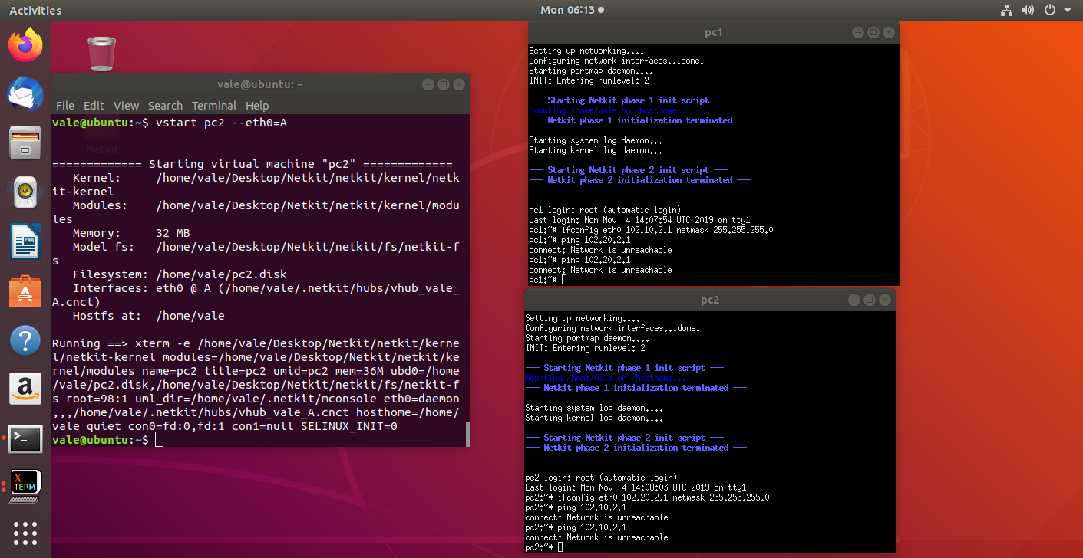

The network is unreachable because we assigned CLASS C IP address to the 2 virtual PCs and we are trying to ping them while being in different networks. For this task to work we need to use the same network address (The first 3 snippets of the IP address). Right now they are different – 102.10.2 and 102.20.2

1. Look at the ARP entries of your Node1 and Node2. Which command do you use? Which ARP entries are there? 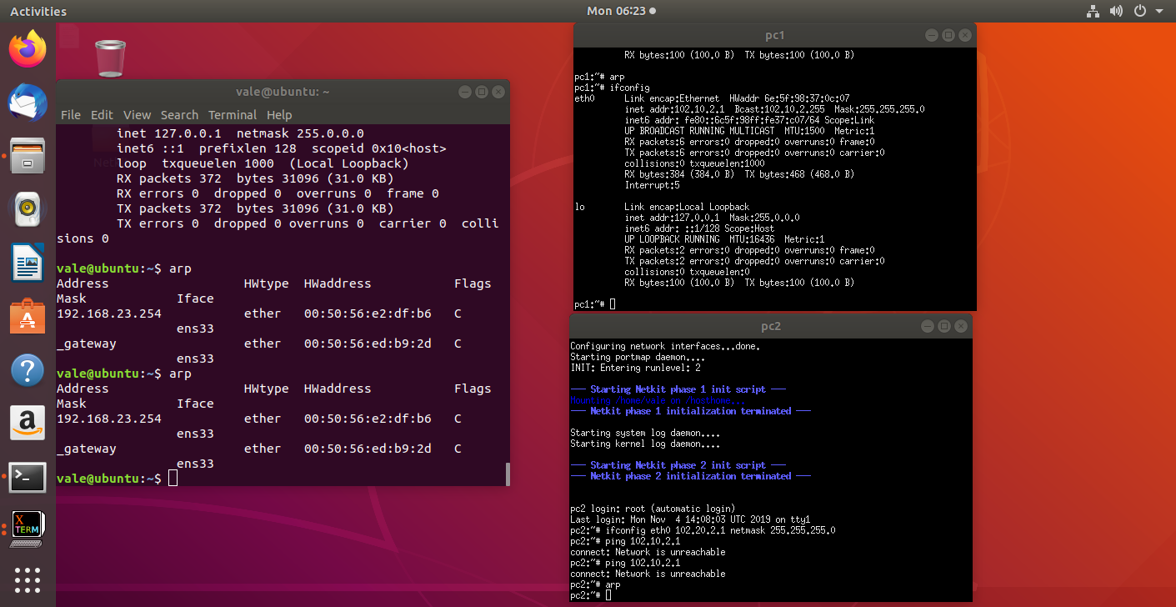The arp command is not returning any entries since we haven’t used the network yet (because it was unavailable). It does however return entries for the Linux’ terminal since we have already used it’s network for something;

B) Configure the IP addresses of the 2 nodes by using the “ip” command explained in the theory lesson.

1. Node1 has an IP address 102.10.2.1/12
2. Node2 has an IP address 102.20.2.1/12

Check whether your configuration was successful by using ping command between these two nodes.

What is the result of the ping? Can you explain it? Provide a screenshot of your configured interfaces. 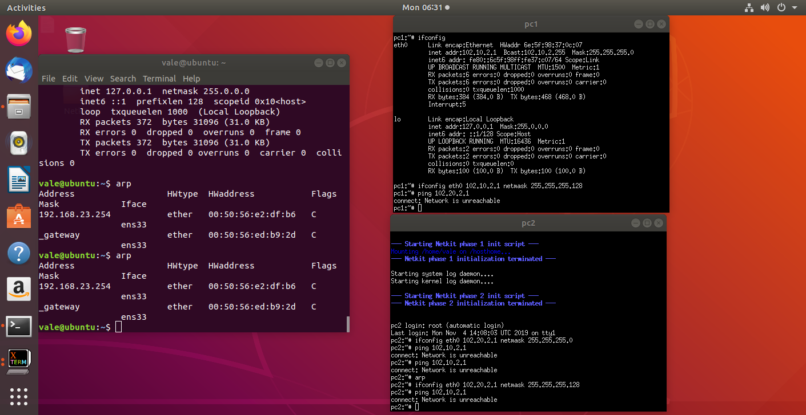

We still cannot ping them since the network is not same, just as the first example. We need to assign the 2 PCs on the same network and assign them a host value between 102.10.2.(129 – 254) because of the subnet mask (255.255.255.128) – we can have only 125 HOST IP addresses;

C) Configure the IP addresses of the 2 nodes in such a way that they subnet mask is 255.255.255.0 and the ping between them is successful.

1. Provide a screenshot of your configuration and successful ping. 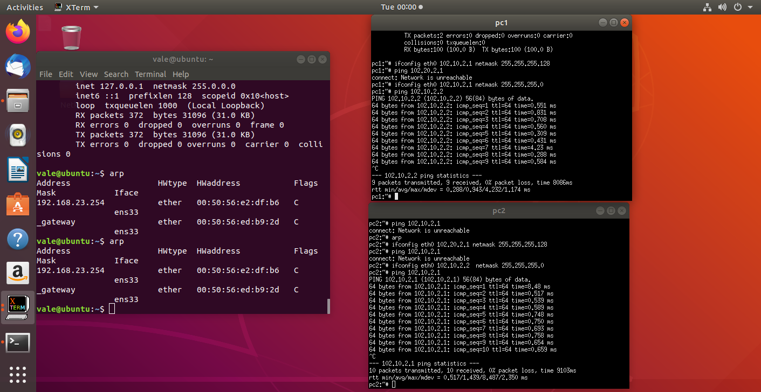

2. After successful ping ARP entries of both nodes should be changed. Provide a screenshot of the new ARP situation and explain it. What is the command to clear the ARP cache again? 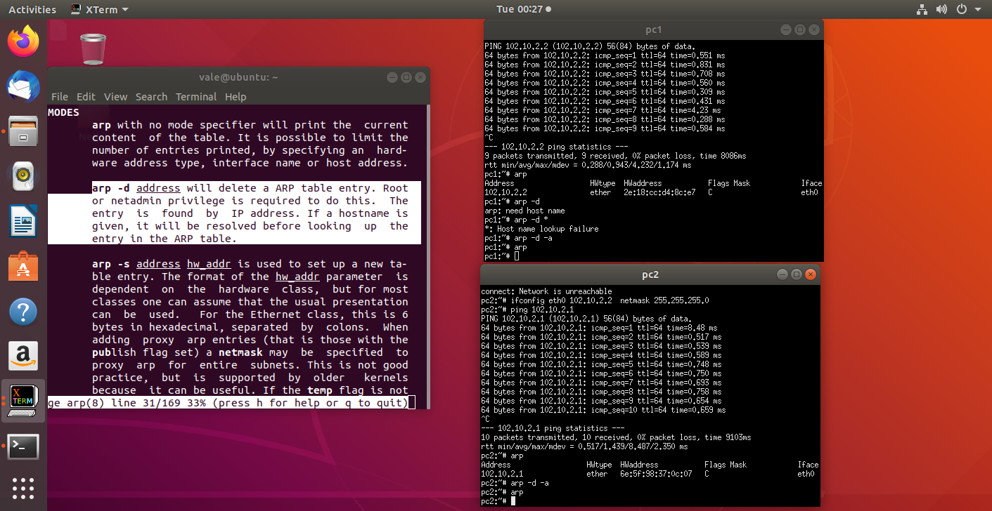

After pinging each other the 2 PCs have used the ARP so they assigned a MAC address to an IP at least once. Here we can see the entries and how to delete all entries.

Task 3: Configuring Network

For this assignment you can use a preconfigured netkit lab provided in net_routing.zip file. To do this you need to copy the provided zip file somewhere in your Linux environment, e.g. in ~/netkit_labs. Unzip the file. You have now a preconfigured lab.

Each simulated node has its own directory. Also, each simulated node has a <node>.startup file where any commands can be added that should be executed before startup of the node.

To start the lab issue the following command in the root directory of your lab:

lstart

Note: When you issue this command, you’ll be prompted for a password which in your case is **student**.

Now all the nodes should be started. However, the nodes are not configured yet. You need to configure them. To do this, please use again the IP addresses as provided in table 1.

There are 2 ways to configure your interfaces:

1. Use either ifconfig or ip commands. Once you know how the commands should look like, it is highly recommended to put them in <node>.startup files, so next time you want to restart and present your lab, you don’t have to reconfigure it by hand again.

Note : Please don’t remove the commands which are already present in the <node>.startup files. They are necessary for starting up Linux networking service.

1. Use <node>/etc/network/interfaces file of the node you want to configure.

In the netkit lab environment you can put any files the contents of which you want to see in the simulated node in the <node> directory. In this way, you can also put there <node>/etc/network/interfaces file. This file is used by Linux system to configure the network interfaces. An example of such a file is provided in the lab for PC1A node.

The network of the lab is as follows:

1. PC1A, PC2A and RouterAC are connected to LANA
2. PC1B, PC2B and RouterBC are connected to LANB
3. PC1C, PC2C, RouterBC, RouterAC and Gateway are connected to LANC
4. Gateway is connected to LANC through fixed eth0 interface with IP address 192.168.1.x/24 and to TAP_LAN through eth1 interface with IP address 192.168.200.1. .LAN is a Netkit-specific interface used for the connection to your guest Linux system. The Gateway node will be used for the optional part of the Assignment 3.
5. Your guest Linux system is connected to your simulated Netkit node Gateway through Netkit specific tap interface nk_tap_student 192.168.200.254, see the detail of the connection between the Netkit simulated environment and your Guest machine in the picture below.



Provide the network drawing of your lab network and screenshots of the pings which are possible WITHIN LANA, LANB and LANC (PC1A to PC2A, PC1B to PC2B and so on). When creating network drawing, don’t forget to mention IP addresses/subnet masks for all nodes of your network. It is also useful to include the names of the network interfaces (eth0, eth1, …).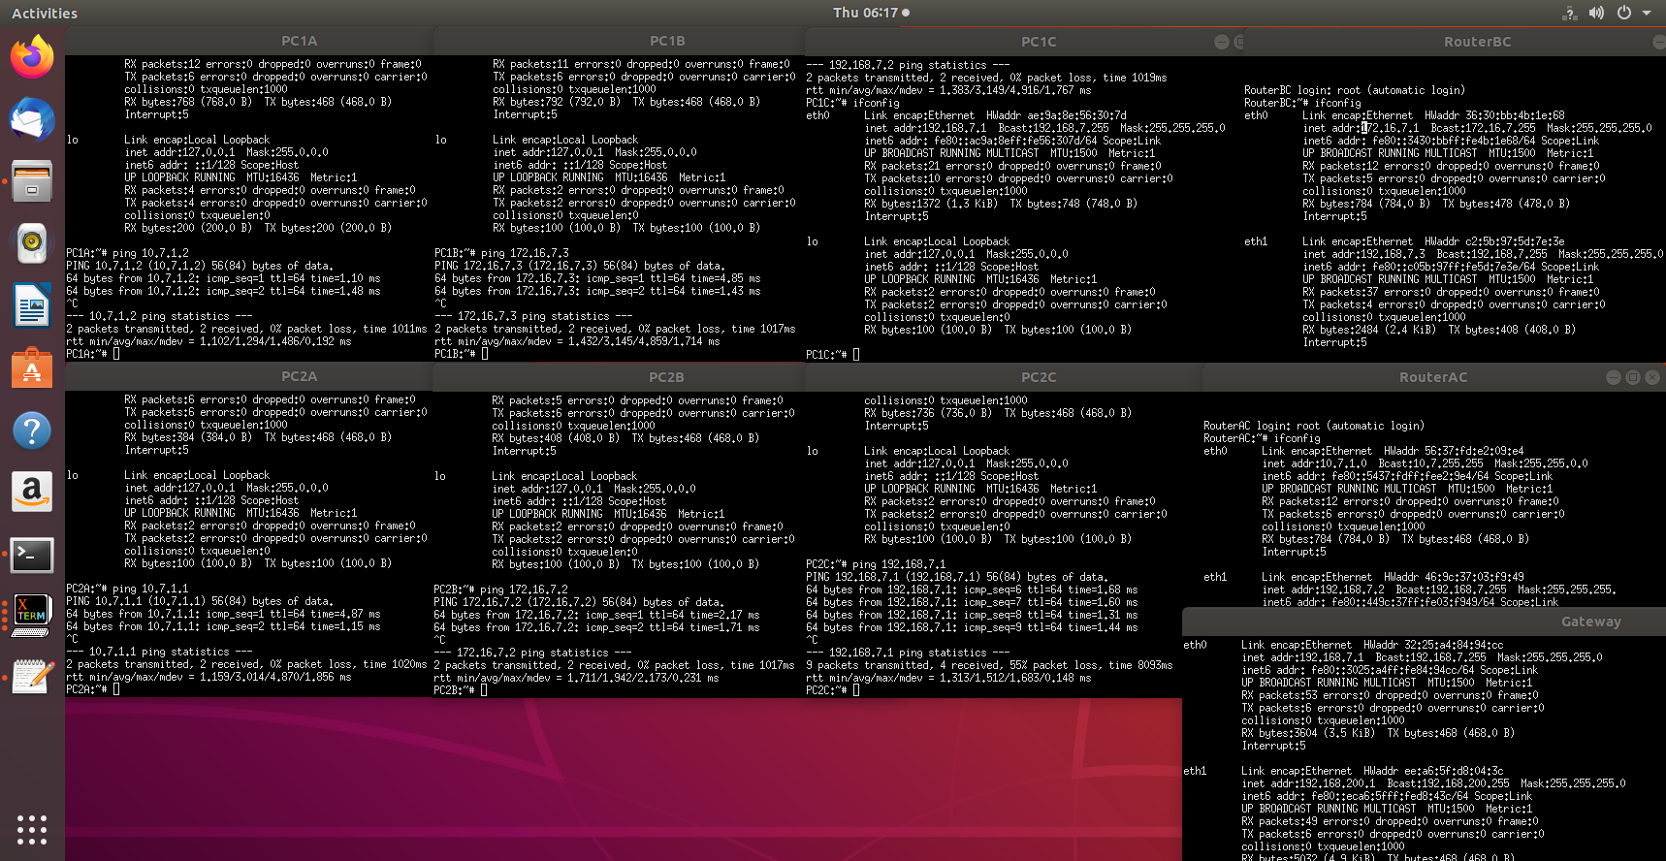

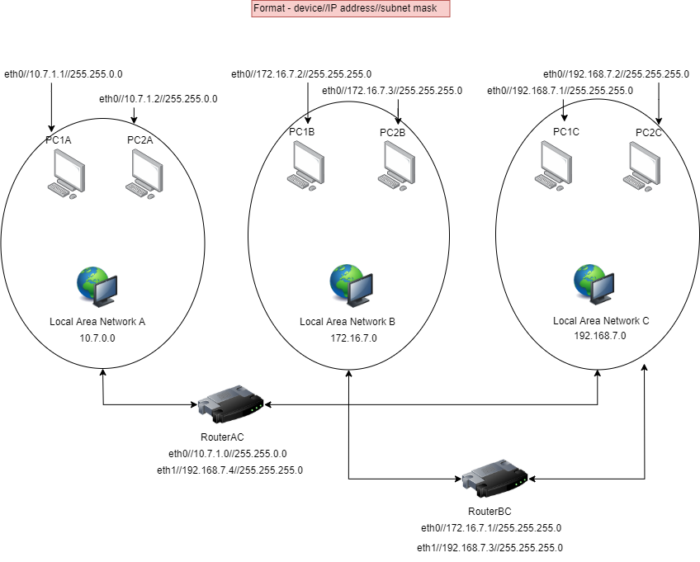

You don’t need to be able to route between all nodes of this network, that is the second part of the assignment, which will be done next week.

Note 1: In the provided netkit lab there are files HOWTO, interfaces.example and Example.startup which can give you more info on how to use and configure the lab.

Table 1 : IPv4 address ranges per group

|  |  |  |  |
| --- | --- | --- | --- |
| Group | LANA | LANB | LANC |
| 1 | 10.1.0.0/16 | 172.16.1.0/24 | 192.168.1.0/24 |
| 2 | 10.2.0.0/16 | 172.16.2.0/24 | 192.168.2.0/24 |
| 3 | 10.3.0.0/16 | 172.16.3.0/24 | 192.168.3.0/24 |
| 4 | 10.4.0.0/16 | 172.16.4.0/24 | 192.168.4.0/24 |
| 5 | 10.5.0.0/16 | 172.16.5.0/24 | 192.168.5.0/24 |
| 6 | 10.6.0.0/16 | 172.16.6.0/24 | 192.168.6.0/24 |
| 7 – Pair 90. | 10.7.0.0/16 | 172.16.7.0/24 | 192.168.7.0/24 |
| 8 | 10.8.0.0/16 | 172.16.8.0/24 | 192.168.8.0/24 |
| 9 | 10.9.0.0/16 | 172.16.9.0/24 | 192.168.9.0/24 |
| 10 | 10.10.0.0/16 | 172.16.10.0/24 | 192.168.10.0/24 |
| 11 | 10.11.0.0/16 | 172.16.11.0/24 | 192.168.11.0/24 |
| 12 | 10.12.0.0/16 | 172.16.12.0/24 | 192.168.12.0/24 |
| 13 | 10.13.0.0/16 | 172.16.13.0/24 | 192.168.13.0/24 |
| 14 | 10.14.0.0/16 | 172.16.14.0/24 | 192.168.14.0/24 |
| 15 | 10.15.0.0/16 | 172.16.15.0/24 | 192.168.15.0/24 |

Task 4: CIDR IP Addressing Exercises

1. Suppose we have IP address 122.33.196.145/24

Fill in the following items for this address:

1. Network Address – 122.33.196.0
2. Broadcast Address – 122.33.196.255
3. Subnet Mask 255.255.255.0

2. Suppose we have IP address 163.249.223.229/25

Fill in the following items for this address:

1. Network Address – 163.249.223.128
2. First Host - 163.249.223.129
3. Last Host - 163.249.223.254
4. Broadcast Address - 163.249.223.255